**Assignment 1**

**(Basics)**

1. Create a webpage that prints the message "When was this webpage created? Check page's title for the answer." to the screen, and set the title of the page to the current date
2. Create a webpage that prints any text of your choosing to the screen write one word smaller than the surrounding text and one word bigger than the surrounding text, do not include a head section in the code.
3. Repeat Ques #2, but this time include a head section in the code.
4. Create a web page to print a paragraph that is a description of a book, include the title of the book as well as its author. Names and titles should be underlined, adjectives should be italicized and bolded.
5. Create a web page to print your name to the screen with every letter being a different heading size.
6. Create a web page to print the squares of the numbers 1 - 20. Each number should be on a separate line, next to it the number 2 superscripted, an equal sign and the result. At the top the page write “Squares of the numbers 1 – 20” in type writer font and at the bottom write Edited by: Your Name
7. Create a web page to print 10 names with a line break between each name with different font and color . The list should be alphabetized, and to do this place a subscripted number next to each name based on where it will go in the alphabetized list. (Example: Alan1). Print first, the unalphabetized list with a subscript number next to each name, then the alphabetized list. Both lists should have an <h1> level heading. e.g.

**Unalphabetized list**

Bill3   
Roger5   
Sandra6   
Stacy7   
William10   
Thomas8   
Wendy9   
Jane4   
Andy1   
Anna2

**Alphabetized list**

Andy   
Anna   
Bill   
Jane   
Roger  
Sandra   
Stacy   
Thomas   
Wendy   
William

1. Create a web page with the text of your choice to implement all logical Inline Elements
2. Create a web page to display some preformatted text of your choosing.
3. Create a web page similar to as shown below and set all the margins of the page of your choice.

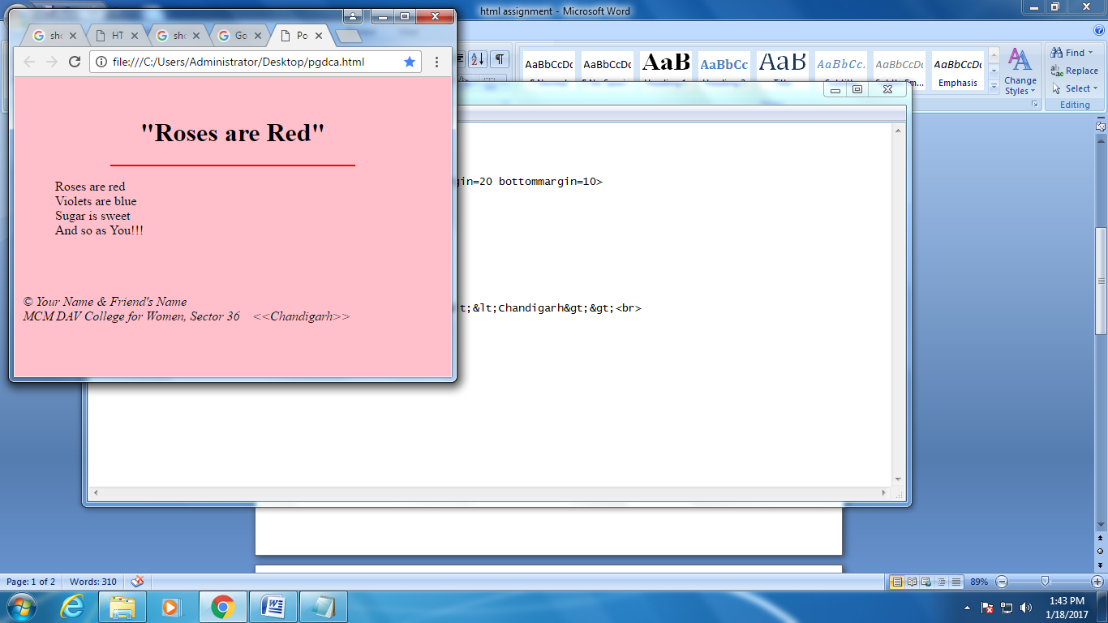

Address tag

Blockquote tag